**9 Scatterplots with Two Y Axes**

This is an addition to section 4 of this guide, “Inserting and Editing a Scatter Plot.” By adding a second Y axis, we can now visualize the relationship between three variables. We are going to plot the relationship between course evaluation (Y1), beauty (Y2), and age (X).

Begin by navigating to the Insert tab, and within the ‘Charts’ group, select the ‘Scatter’ drop-down box, and select the first option (a series of unconnected points).

Unlike our first scatter plot, this should pop up as a white empty box. This is because we have not indicated what data should be put into our chart yet. To add data, we will navigate to the ‘Select Data’ pop-up by right clicking on the chart.

Add two data series, one that course evaluation as the Y and age as the X, and another that is beauty as the Y and age as the X.

Your ‘Select Data’ window and unedited chart should look something like this:

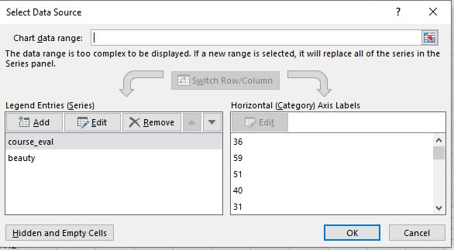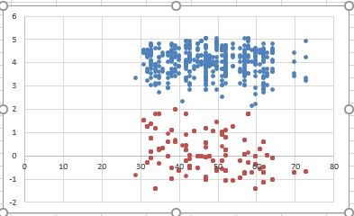

Notice that there is currently only one Y axis, so we must format our chart to make the information we are trying to convey clear.

First, let’s start by telling Excel that we want to represent two Y axes. Start by clicking on one point on the chart to format the data series, and in the side pop-up window, navigate to the ‘Series Options’ tab (the bar chart icon) and choose the option ‘Secondary Axis.” Now, you should have two axes! For most-readable results, the beauty variable should correspond to the second axis.

Now, let’s format the rest of the chart referring to previous instructions:

Add a chart title: “Beauty, Course Evaluations, and Age (in section 4)

Add Axes titles corresponding to the variables (in section 4)

Change the beauty Y Axis to have 2 decimal points (in section 5)

Delete the gridlines (in section 4)

Add a legend and orient it towards the bottom of the chart (in section 4)

Find suitable colors for data markers (in section 4)

Your final chart should look something like this:

